**Refactoring Techniques**

**Composing Methods**

**Extract Method**

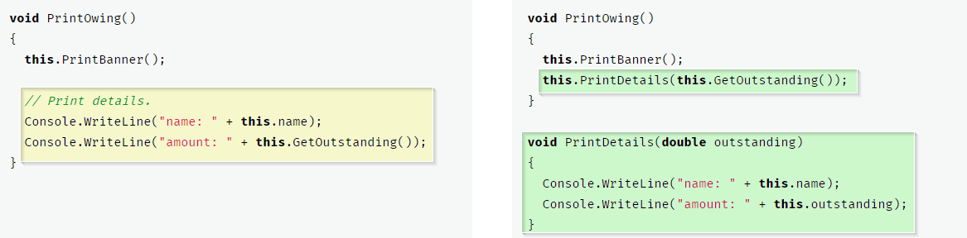

**Inline Method**

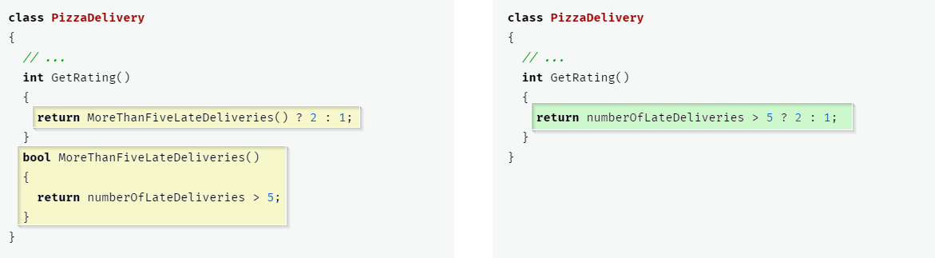

**Extract Variable**

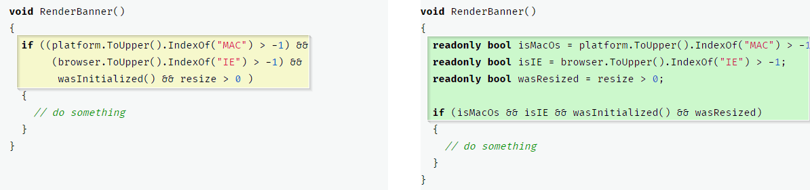

**Inline Temp**

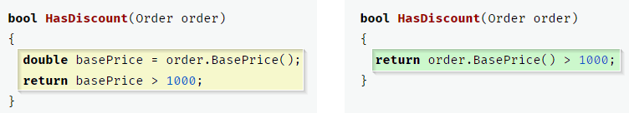

**Replace Temp with Query**

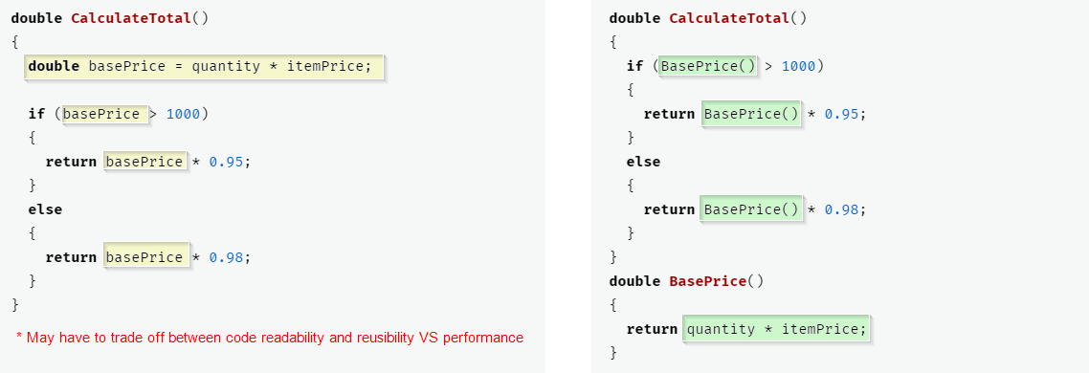

**Replace Method with Method Object**

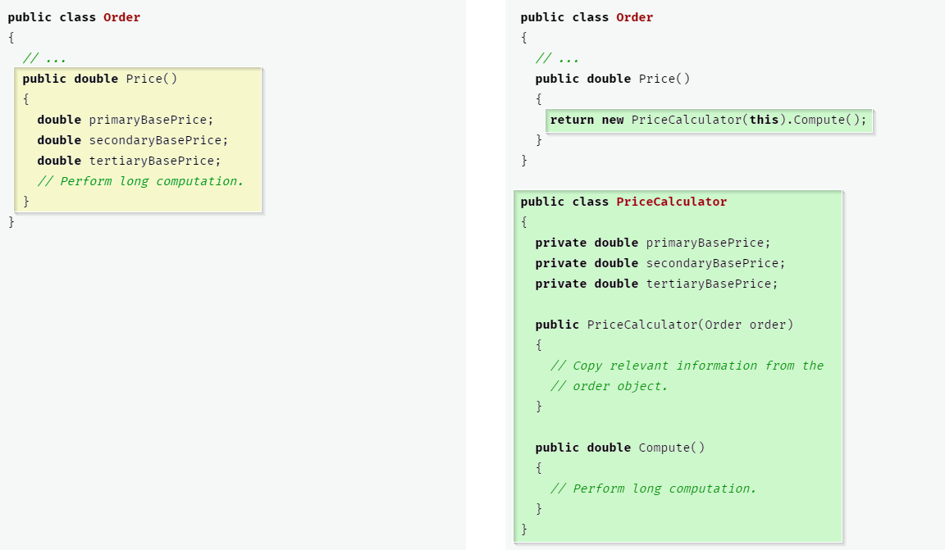

**Split Temporary Variable**

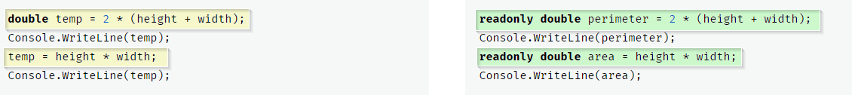

**Remove Assignments to Parameters**

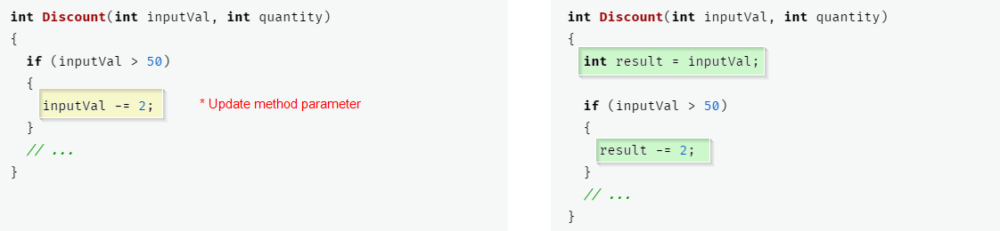

**Substitute Algorithm**

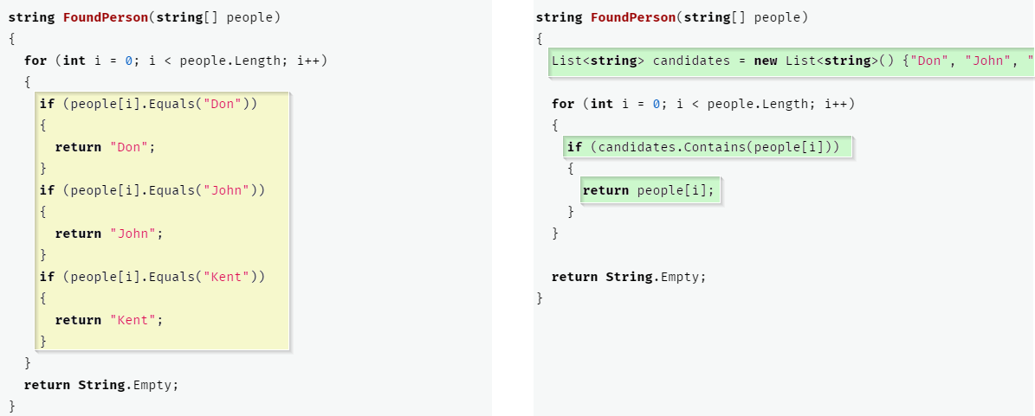

**Moving Features between Objects**

**Move Method**

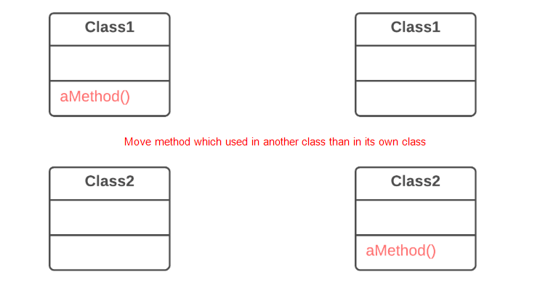

**Move Field**

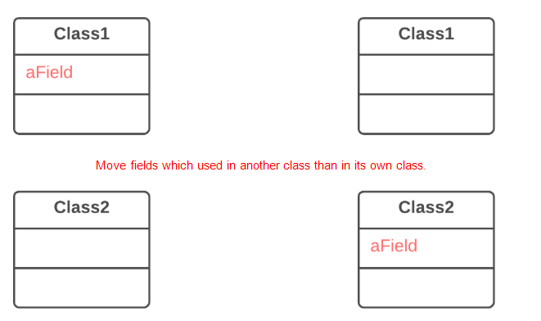

**Extract Class**

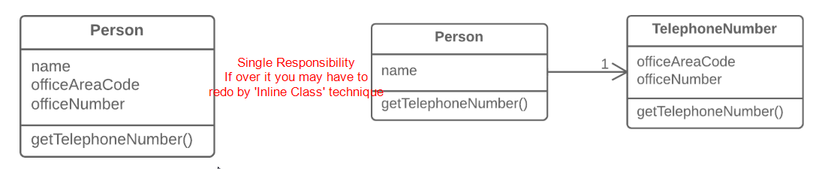

**Inline Class**

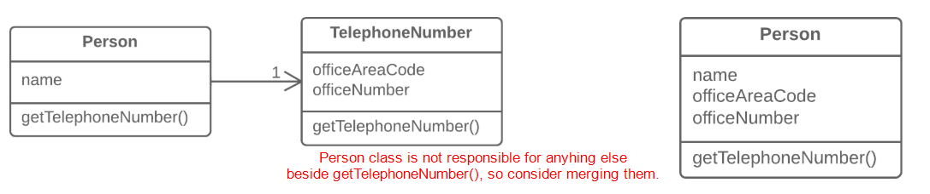

**Hide Delegate**

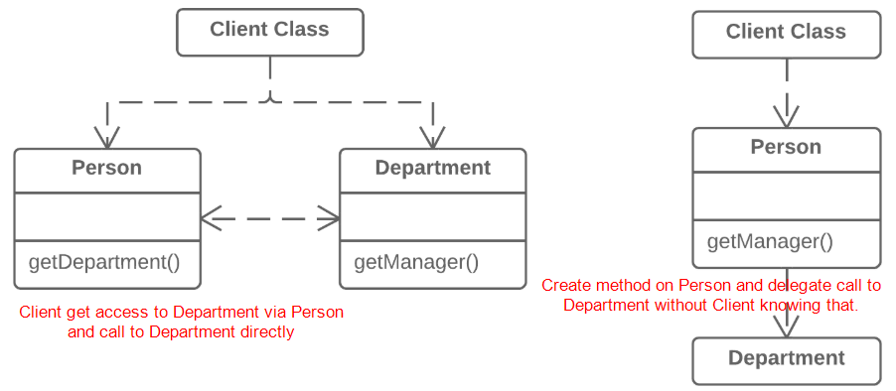

**Remove Middleman**

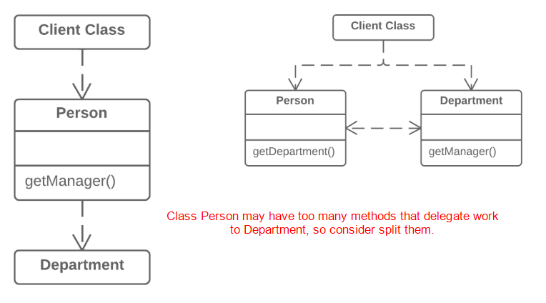

**Introduce Foreign Method**

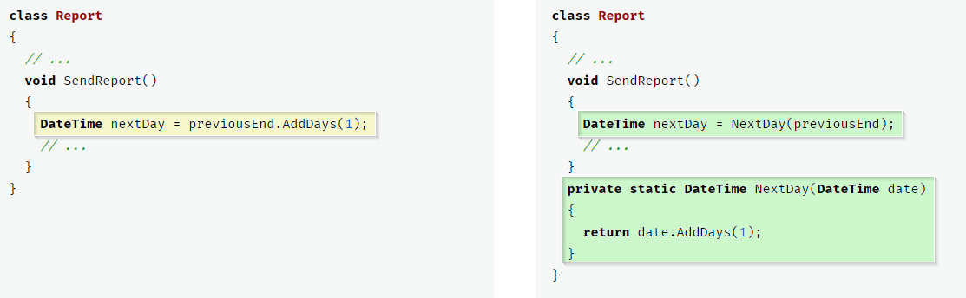

**Introduce Local Extension**

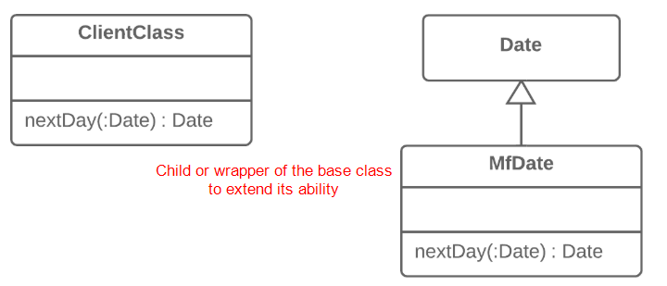

**Organizing Data**

**Self-Encapsulate Field**

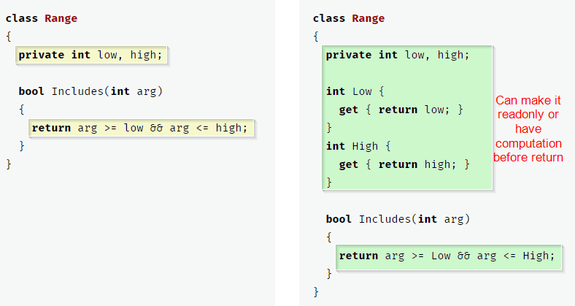

**Encapsulate Field**

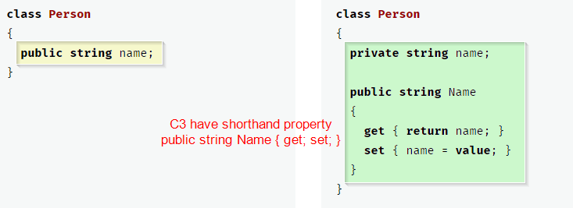

**Change Value to Reference**

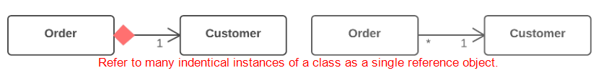

**Change Reference to Value**

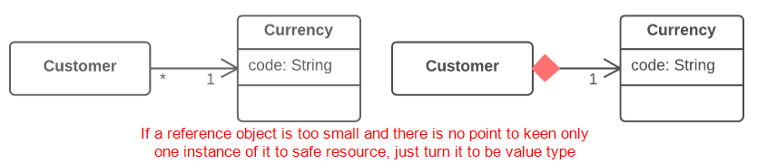

**Replace Data Value with Object**

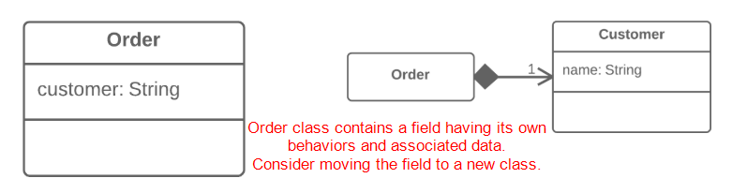

**Replace Array with Object**

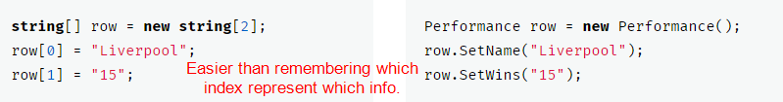

**Encapsulate Collection**

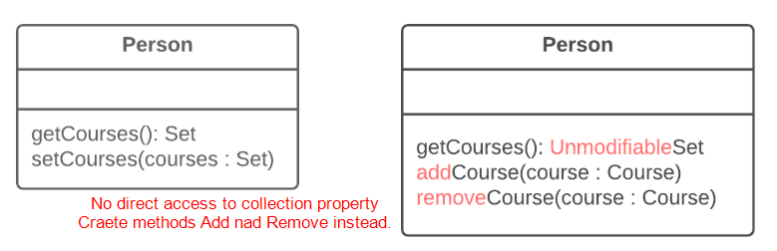

**Change Unidirectional Association to Bidirectional**

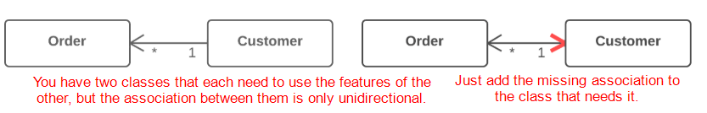

**Change Bidirectional Association to Unidirectional**

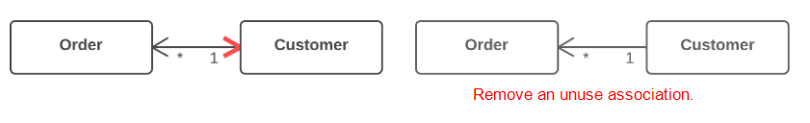

**Replace Magic Number with Symbolic Constant**

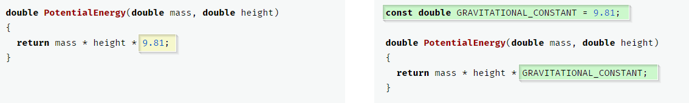

**Duplicate Observed Data**

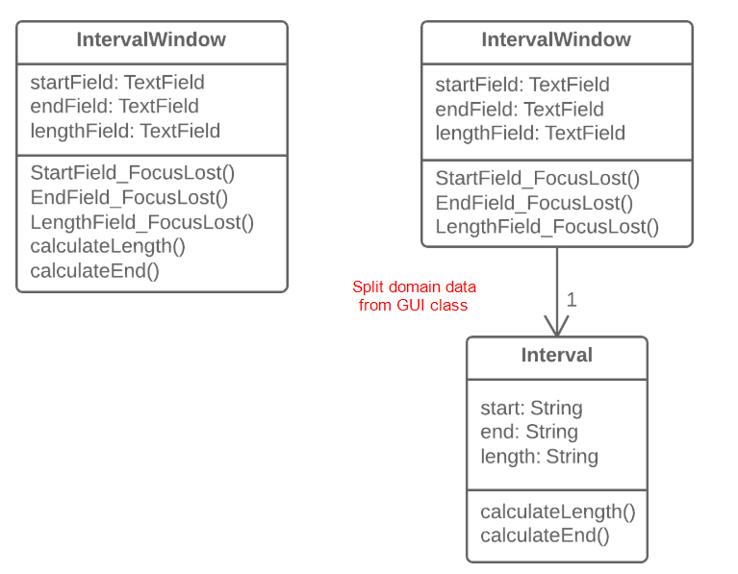

**Replace Type Code with Class**

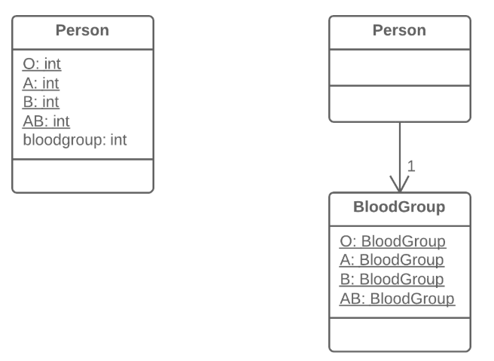

**Replace Type Code with Subclasses**

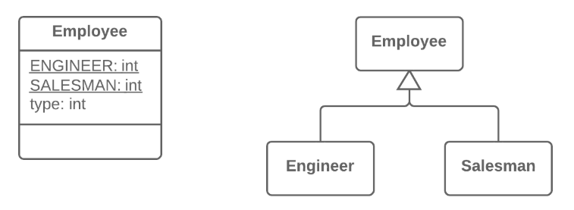

**Replace Type Code with State/Strategy**

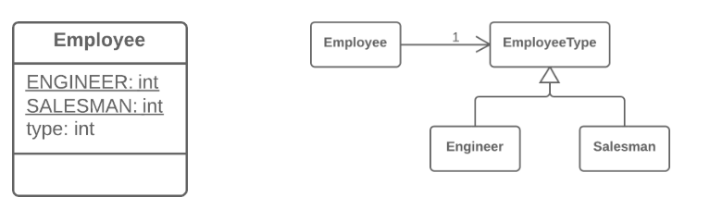

**Replace Subclass with Fields**

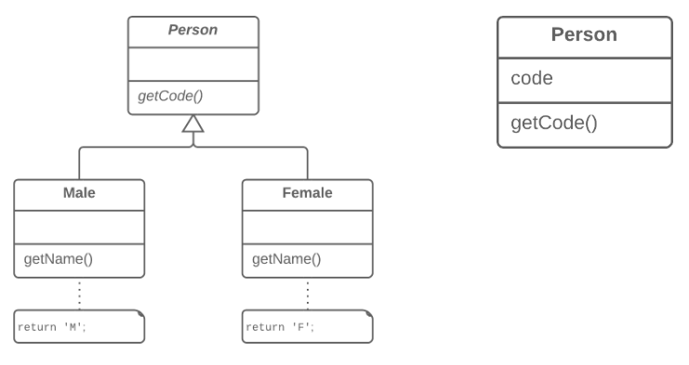

**Simplifying Conditional Expressions**

**Decompose Conditional**

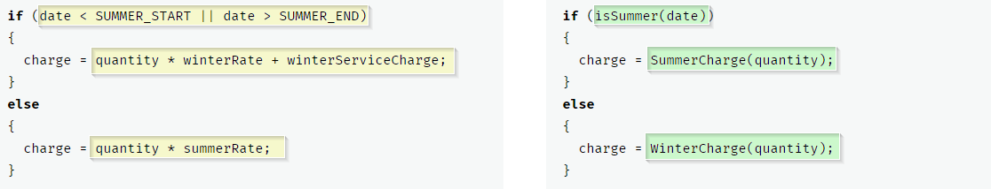

**Consolidate Conditional Expression**

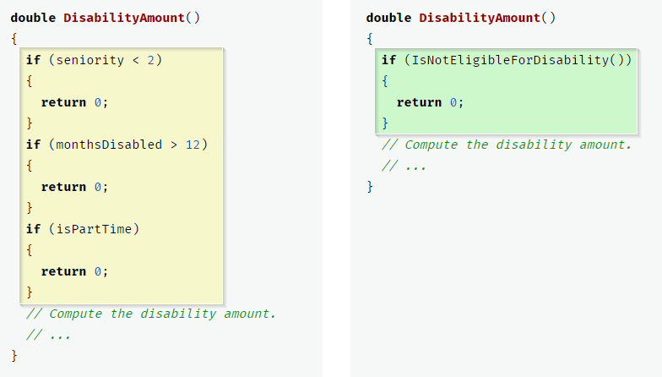

**Consolidate Duplicate Conditional Fragments**

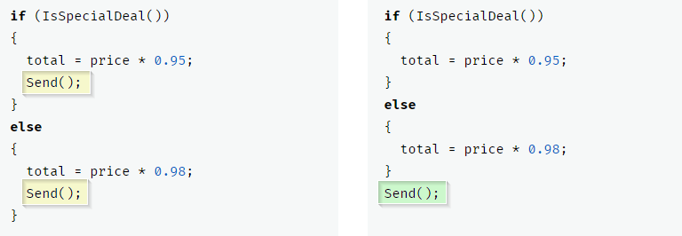

**Remove Control Flag**

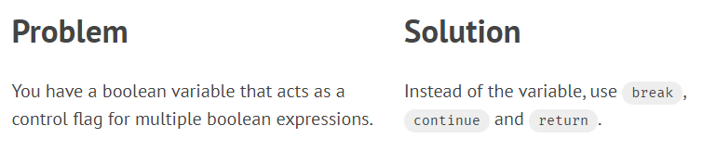

**Replace Nested Conditional with Guard Clauses**

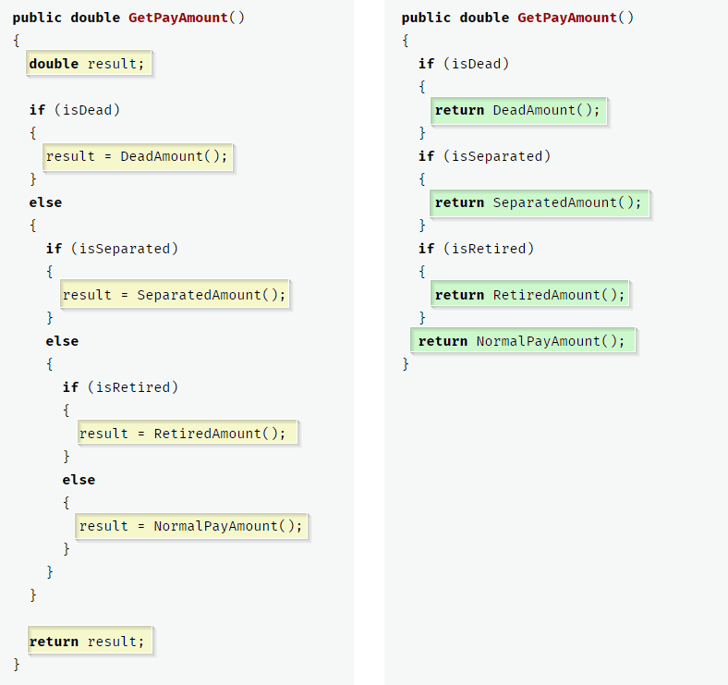

**Introduce Assertion**

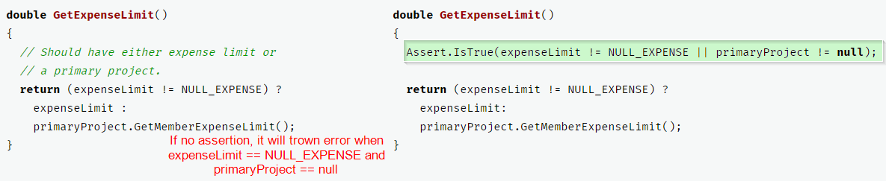

**Replace Conditional with Polymorphism**

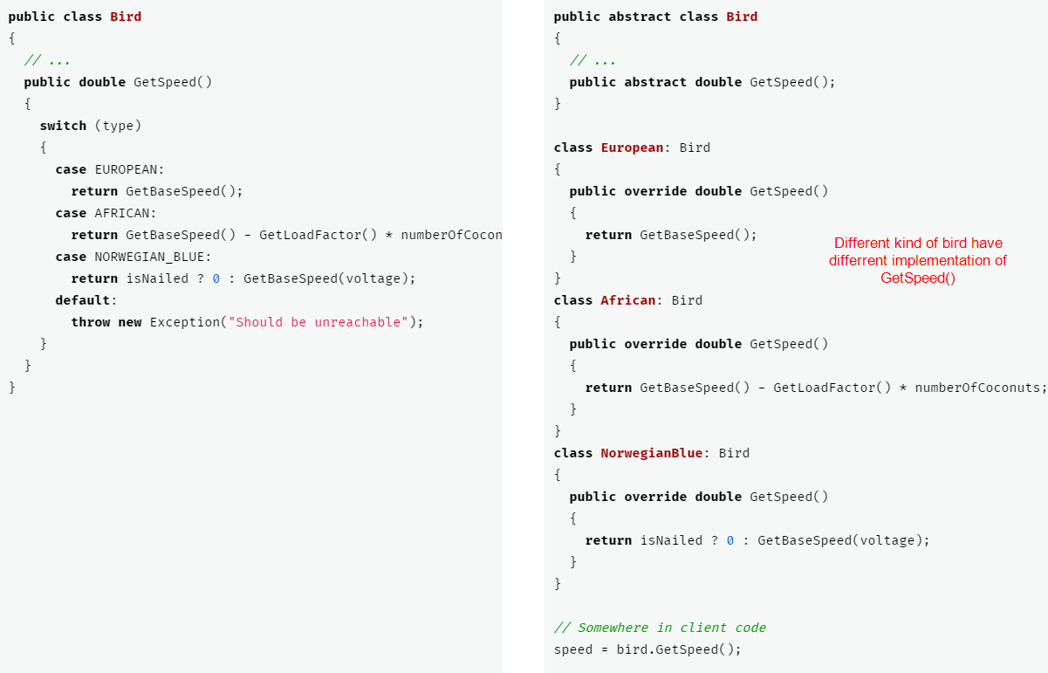

**Introduce Null Object**

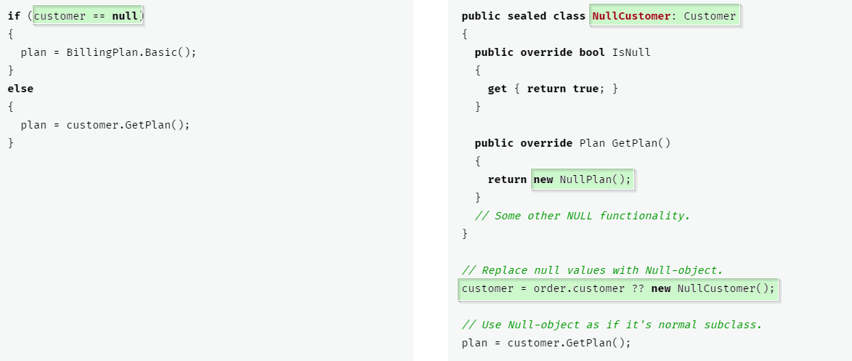

### [**Simplifying Method Calls**](https://refactoring.guru/refactoring/techniques/simplifying-method-calls)

**Rename Method**

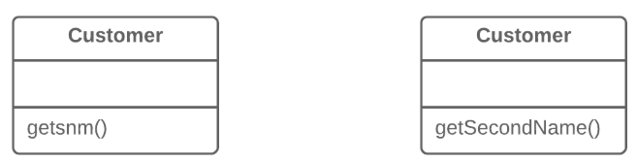

**Add Parameter**

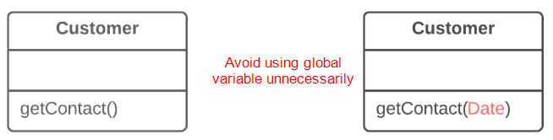

**Remove Unused Parameter**

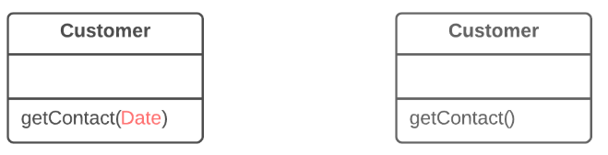

**Separate Query from Modifier**

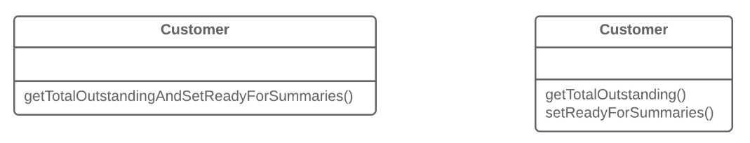

**Parameterize Method**

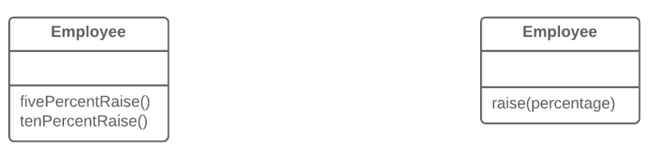

**Preserve Whole Object**



**Replace Parameter with Method Call**

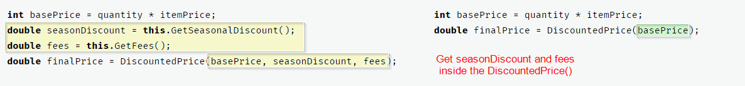

**Replace Parameter with Explicit Methods**

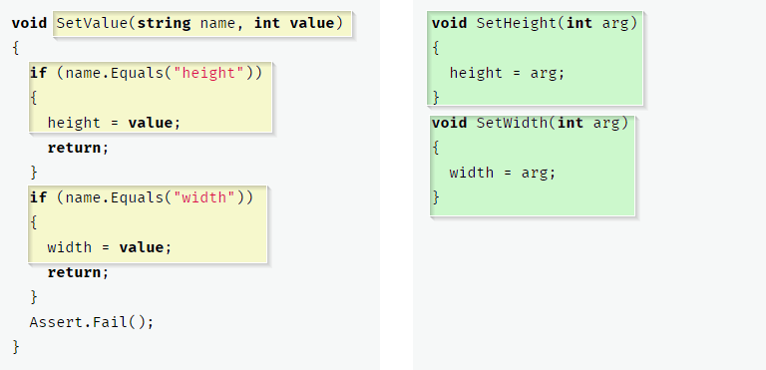

**Introduce Parameter Object**

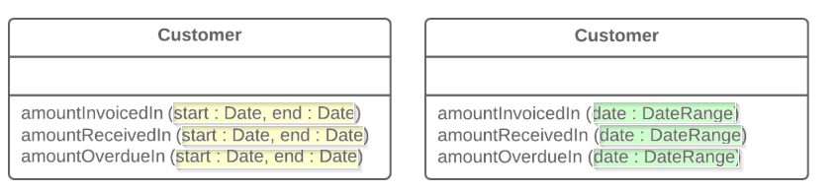

**Remove Setting Method for Immutable Fields**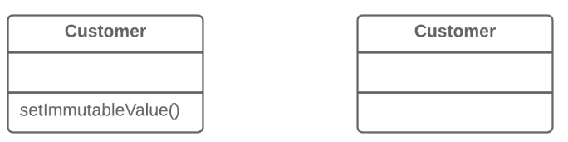

**Hide Method that should not be Public**

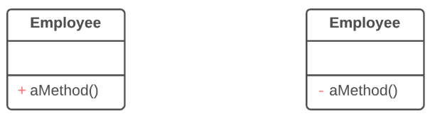

**Replace Constructor with Factory Method**

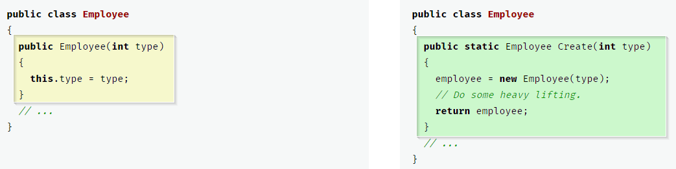

**Replace Error Code with Exception**

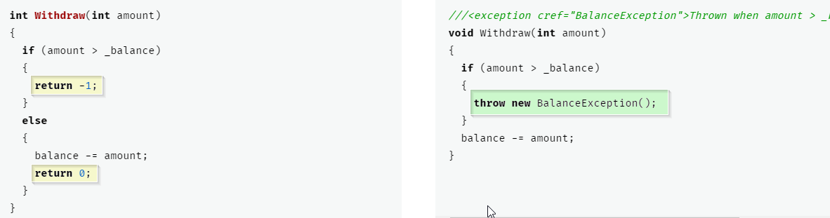

**Replace Exception with Test**

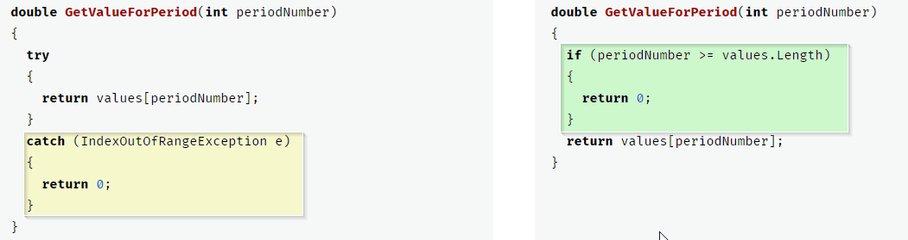

**Dealing with Generalization**

**Pull Up Field**

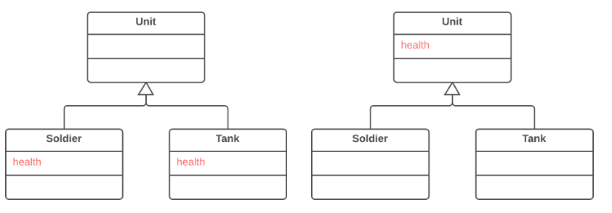

**Pull Up Method**

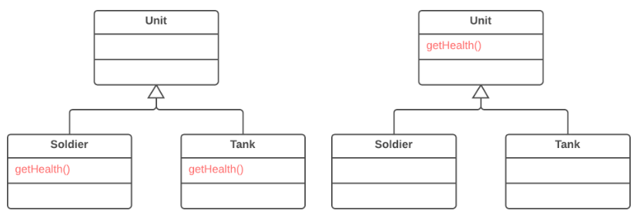

**Pull Up Constructor Body**

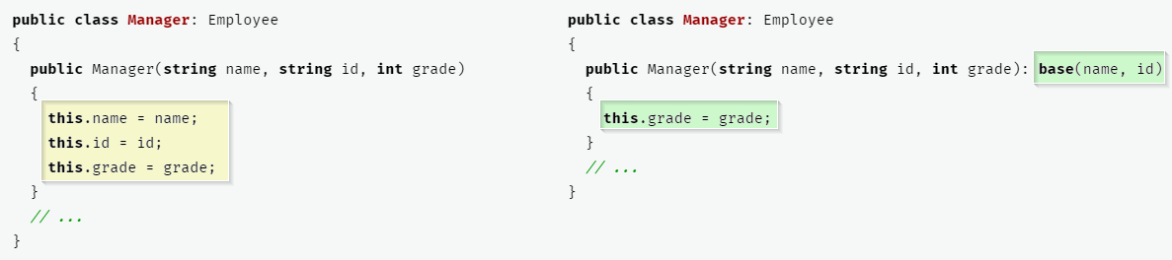

**Push Down Field**

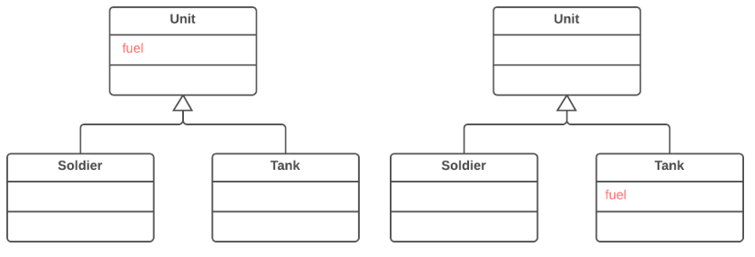

**Push Down Method**

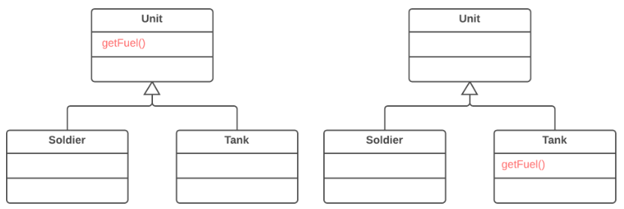

**Extract Subclass**

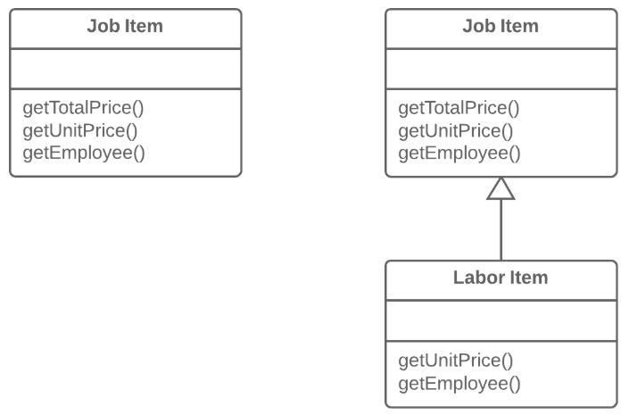

**Extract Superclass**

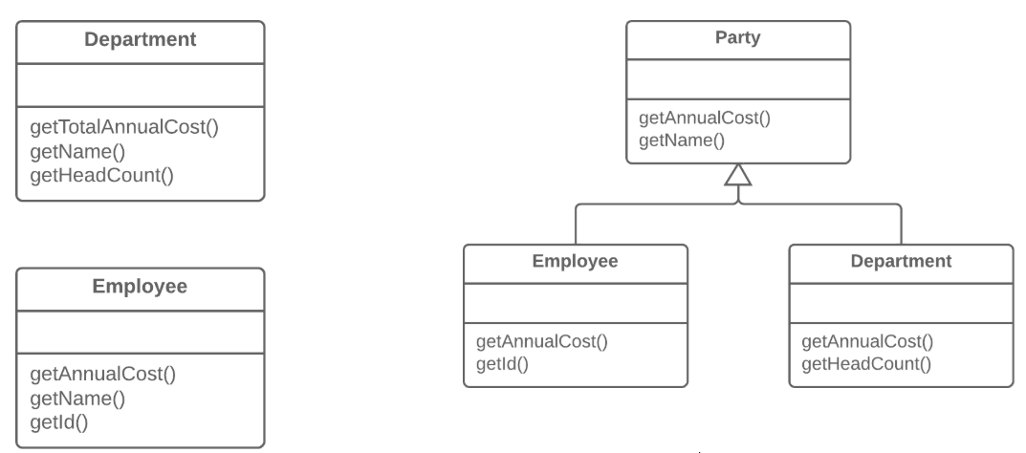

**Collapse Hierarchy**

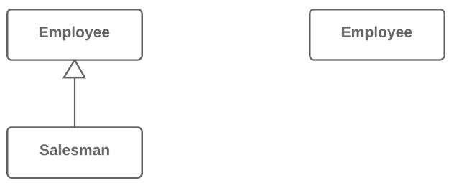

**Extract Interface**

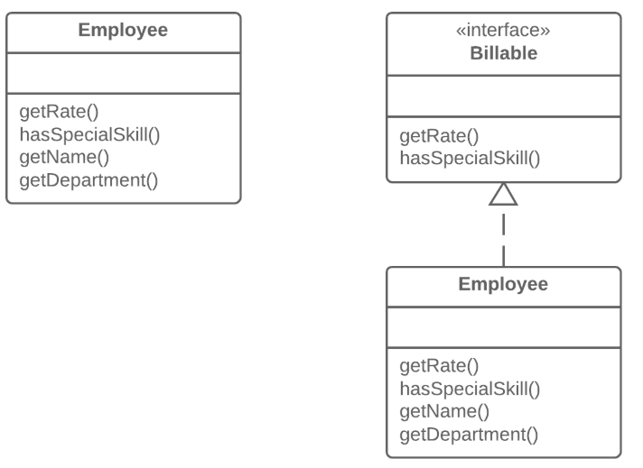

**Form Template Method**

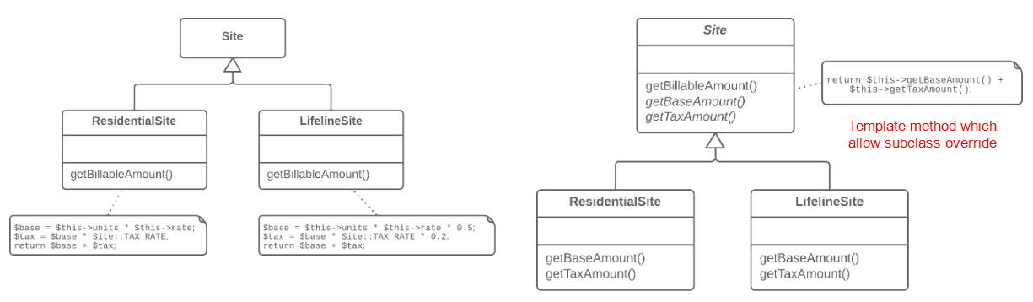

**Replace Inheritance with Delegation**

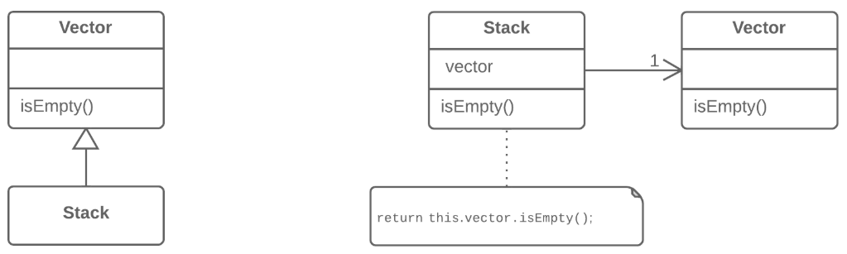

**Replace Delegation with Inheritance**

